

# 

### Semester One Examination, 2017

### Question/Answer booklet

# MATHEMATICS

**SOLUTIONS**

**METHODS**

**UNIT 1**

## Section One:

## Calculator-free

|  |  |  |  |  |  |  |  |  |  |  |
| --- | --- | --- | --- | --- | --- | --- | --- | --- | --- | --- |
| Student Number: In figures |  |  |  |  |  |  |  |  |  |  |

In words

Your name

## Time allowed for this section

Reading time before commencing work: five minutes

Working time: fifty minutes

## Materials required/recommended for this section

***To be provided by the supervisor***

This Question/Answer booklet

Formula sheet

***To be provided by the candidate***

Standard items: pens (blue/black preferred), pencils (including coloured), sharpener, correction fluid/tape, eraser, ruler, highlighters

Special items: nil

## Important note to candidates

No other items may be taken into the examination room. It is **your** responsibility to ensure that you do not have any unauthorised material. If you have any unauthorised material with you, hand it to the supervisor **before** reading any further.

## Structure of this paper

|  |  |  |  |  |  |
| --- | --- | --- | --- | --- | --- |
| Section | Number of questions available | Number of questions to be answered | Working  time (minutes) | Marks available | Percentage of examination |
| Section One:  Calculator-free | 7 | 7 | 50 | 52 | 35 |
| Section Two:  Calculator-assumed | 13 | 13 | 100 | 98 | 65 |
|  | | |  | **Total** | 100 |

## Instructions to candidates

1. The rules for the conduct of examinations are detailed in the school handbook. Sitting this examination implies that you agree to abide by these rules.

2. Write your answers in this Question/Answer booklet.

3. You must be careful to confine your response to the specific question asked and to follow any instructions that are specified to a particular question.

4. Additional working space pages at the end of this Question/Answer booklet are for planning or continuing an answer. If you use these pages, indicate at the original answer, the page number it is planned/continued on and write the question number being planned/continued on the additional working space page.

5. Show all your working clearly. Your working should be in sufficient detail to allow your answers to be checked readily and for marks to be awarded for reasoning. Incorrect answers given without supporting reasoning cannot be allocated any marks. For any question or part question worth more than two marks, valid working or justification is required to receive full marks. If you repeat any question, ensure that you cancel the answer you do not wish to have marked.

6. It is recommended that you do not use pencil, except in diagrams.

7. The Formula sheet is not to be handed in with your Question/Answer booklet.

Section One: Calculator-free 35% (52 Marks)

This section has**seven (****7)** questions. Answer **all** questions. Write your answers in the spaces provided.

Working time: 50 minutes.

Question 1 (6 marks)

(a) On the axes below, sketch the graph of the relation $y^{2}=x$, labelling all key features with their coordinates or equations. (3 marks)

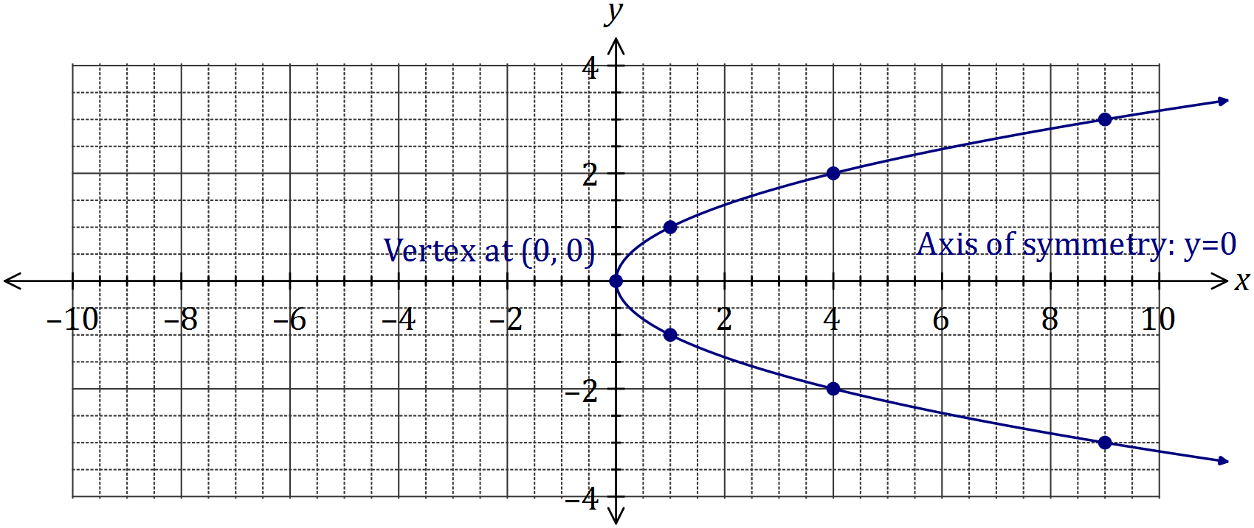

|  |
| --- |
| **Solution** |
| See graph |
| **Specific behaviours** |
| ✓ smooth curve through at least 5 out of 7 marked points  ✓ labels vertex  ✓ labels axis of symmetry |

(b) Determine the equation of the circle shown below. (3 marks)

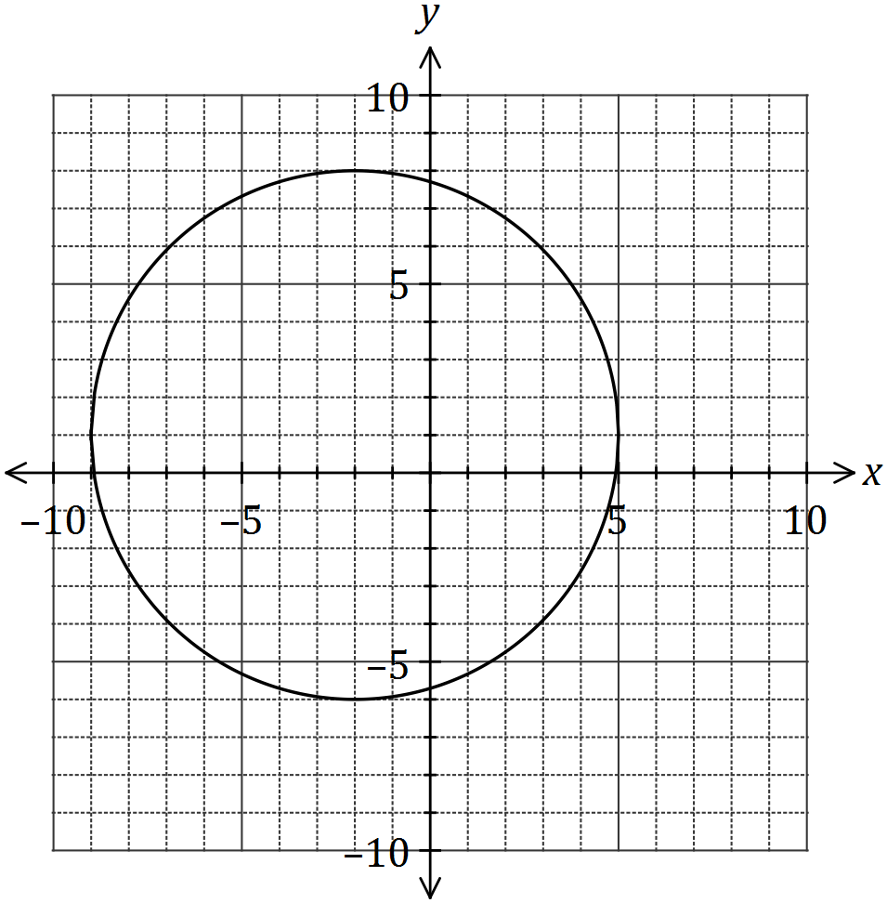

|  |
| --- |
| **Solution** |
| $${\left(x+2\right)}^{2}+{\left(y-1\right)}^{2}=49$$ |
| **Specific behaviours** |
| ✓ uses standard form for circle  ✓ uses correct centre  ✓ uses correct radius |

Question 2 (9 marks)

(a) The point $M(8, 1)$ is the midpoint of $A$ and $B(20, 7)$. Determine the coordinates of $A$.

(2 marks)

|  |
| --- |
| **Solution** |
| $$\frac{20+x}{2}=8 \text{and}\frac{7+y}{2}=1$$ $$x=-4, y=-5⇒ A(-4, -5)$$ |
| **Specific behaviours** |
| ✓ writes equations  ✓ states coordinates of $A$ |

(b) A relationship between $x$ and $y$ is given by $x=2y-3$.

(i) Determine $y$ when $x=25$. (1 mark)

|  |
| --- |
| **Solution** |
| $$25=2y-3⇒y=14$$ |
| **Specific behaviours** |
| ✓ states value |

(ii) State, with justification, whether $x$ is a function of $y$. (2 marks)

|  |
| --- |
| **Solution** |
| Yes.  All values of the domain ($y$) are mapped to one value of the range ($x$). |
| **Specific behaviours** |
| ✓ states yes  ✓ reasoning includes one output for each input |

(c) A straight line passes through points $C(2, -5)$ and $D(-2, 2)$. Determine the equation of the straight line that is perpendicular to this line and passes through $C$, expressing your answer in the form $ax+by+c=0$, where $a$, $b$ and $c$ are integers. (4 marks)

|  |
| --- |
| **Solution** |
| $$m_{CD}=-\frac{7}{4}⇒m_{⊥}=\frac{4}{7}$$ $$y-\left(-5\right)=\frac{4}{7}\left(x-2\right)⇒-4x+7y+43=0$$ |
| **Specific behaviours** |
| ✓ determines gradient of CD  ✓ determines perp. Gradient  ✓ writes equation of line  ✓ writes equation in required form |

Question 3 (7 marks)

Solve each of the following equations for the variable $x$.

(a) $3\left(1-x\right)+4=2(2x-7)$. (2 marks)

|  |
| --- |
| **Solution** |
| $$3-3x+4=4x-14 \\ 21=7x⇒x=3$$ |
| **Specific behaviours** |
| ✓ expands  ✓ simplifies and solves |

(b) $\frac{x}{2}$ $=1+$ $\frac{2x}{5}$. (2 marks)

|  |
| --- |
| **Solution** |
| $$\frac{x}{2}=\frac{5+2x}{5} \\ 5x=10+4x \\ x=10$$ |
| **Specific behaviours** |
| ✓ eliminates denominators  ✓ solves |

(c) $\frac{4}{x}$ $=3+x$. (3 marks)

|  |
| --- |
| **Solution** |
| $$4=3x+x^{2}⇒x^{2}+3x-4=0 \\ \left(x+4\right)\left(x-1\right)=0 \\ x=-4, x=1$$ |
| **Specific behaviours** |
| ✓ equates to zero  ✓ factors  ✓ solves |

Question 4 (8 marks)

(a) Solve the equation $x^{3}=7x^{2}+30x$. (4 marks)

|  |
| --- |
| **Solution** |
| $$x^{3}-7x^{2}-30x=0$$ $$x\left(x^{2}-7x-30\right)=0$$ $$x\left(x-10\right)\left(x+3\right)=0$$ $$x=0, x=10, x=-3$$ |
| **Specific behaviours** |
| ✓ equates to zero  ✓ factors out  ✓ factors quadratic  ✓ states all solutions |

(b) The graph of $y=ax^{3}+bx^{2}+cx+d$ is shown below. Determine the values of the constants $a$, $b$, $c$ and $d$. (4 marks)

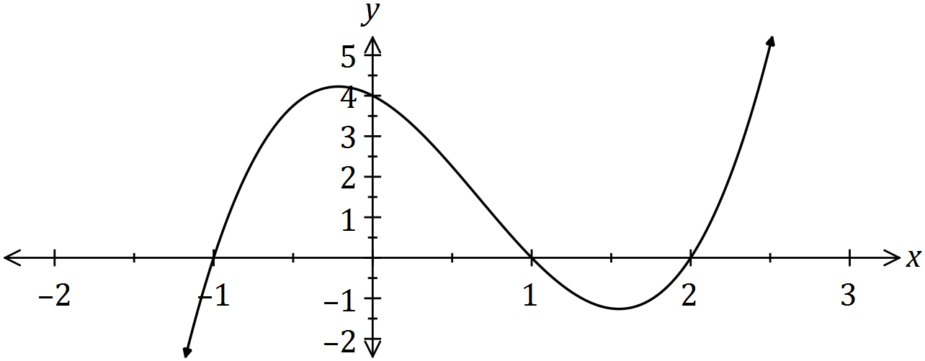

|  |
| --- |
| **Solution** |
| $$y=a\left(x+1\right)\left(x-1\right)\left(x-2\right)$$ $$x=0, y=4⇒4=2a, a=2$$ $$y=2\left(x^{2}-1\right)\left(x-2\right)=2\left(x^{3}-2x^{2}-x+2\right)$$ $$a=2, b=-4, c=-2, d=4$$ |
| **Specific behaviours** |
| ✓ writes factors from roots  ✓ determines  ✓ expands  ✓ states all values |

Question 5 (6 marks)

A function is defined as $f\left(x\right)=x^{3}-5x^{2}-12x+36$.

(a) Evaluate $f(2)$. (1 mark)

|  |
| --- |
| **Solution** |
| $$f\left(2\right)=8-20-24+36=0$$ |
| **Specific behaviours** |
| ✓ evaluates |

(b) Factorise $f(x)$. (3 marks)

|  |
| --- |
| **Solution** |
| $$x^{3}-5x^{2}-12x+36=\left(x-2\right)\left(x^{2}+ax-18\right)$$ $$-5=-2+a⇒-3 (\text{using} x^{2} \text{coeff)}$$ $$\left(x-2\right)\left(x^{2}-3x-18\right)=\left(x-2\right)\left(x+3\right)\left(x-6\right)$$ |
| **Specific behaviours** |
| ✓ obtains quadratic factor with unknown  ✓ deduces value of  ✓ completes factorisation |

(c) Hence, or otherwise, solve $f\left(x\right)=(x-2)(x-3)(x-6)$ (2 marks)

|  |
| --- |
| **Solution** |
| $$\left(x-2\right)\left(x+3\right)\left(x-6\right)=\left(x-2\right)\left(x-3\right)\left(x-6\right)$$ $$\left(x-2\right)\left(x-6\right)\left(x+3-x+3\right)=0$$ $$6\left(x-2\right)\left(x-6\right)=0$$ $$x=2, x=6$$ |
| **Specific behaviours** |
| ✓ rearranges to equal zero  ✓ states both solutions |

Question 6 (8 marks)

(a) For the graph with equation $y=(x+1)(x-3)$, determine the coordinates of

(i) all axes intercepts. (2 marks)

|  |
| --- |
| **Solution** |
| $y$-intercept: $(0, -3)$. $x$-intercepts: $(-1, 0)$ and $(3, 0)$ |
| **Specific behaviours** |
| ✓ -intercept  ✓ -intercepts and all answers written as coordinates |

(ii) the turning point. (2 marks)

|  |
| --- |
| **Solution** |
| Line of symmetry: $x=1$ $y=\left(1+1\right)\left(1-3\right)=-4$  TP at $(1, -4)$ |
| **Specific behaviours** |
| ✓ -coordinate  ✓ turning point in coordinate form |

(b) The graphs of three quadratic functions with discriminants of 0, 1 and -2 are shown below.

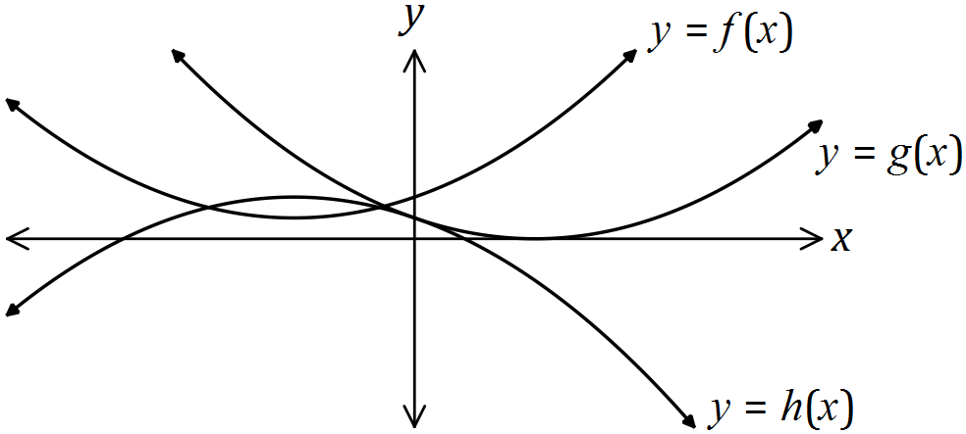

|  |
| --- |
| **Solution (i)** |
| see table |
| **Specific behaviours** |
| ✓ at least one correct  ✓ all correct |

(i) Underneath each function in this table, write the value of it's discriminant.

(2 marks)

|  |  |  |  |
| --- | --- | --- | --- |
| Function | $$f(x)$$ | $$g(x)$$ | $$h(x)$$ |
| Discriminant | -2 | 0 | 1 |

(ii) Clearly explain your choices in part (i). (2 marks)

|  |
| --- |
| **Solution (ii)** |
| $f$ has no roots, $g$ has 1 root and $h$ has two roots. Discriminant is: -ve, no roots; 0, one root; and +ve, two roots. |
| **Specific behaviours** |
| ✓ states number of roots of each function  ✓ explains use of discriminant |

Question 7 (8 marks)

(a) If $α$ and $β$ are acute angles such that $\cos{α}=\frac{2}{3}$ and $\sin{β}=\frac{3}{5}$, determine the value of $\cos{(α-β)}$ as a single fraction. (4 marks)

|  |
| --- |
| **Solution** |
| From 3-4-5 right-triangle, $\cos{β=\frac{4}{5}}$ From 2- $\sqrt{5}$-3 right-triangle, $\sin{α}=\frac{\sqrt{5}}{3}$ Using identity, $\cos\left(α-β\right)=\frac{2}{3}×\frac{4}{5}+\frac{\sqrt{5}}{3}×\frac{3}{5}=\frac{8+3\sqrt{5}}{15}$ |
| **Specific behaviours** |
| ✓ states  ✓ states  ✓ uses identity  ✓ simplifies |

(b) Solve the following equations.

(i) $\sqrt{2}\sin{x}=-1$ where $0≤x≤2π$. (2 marks)

|  |
| --- |
| **Solution** |
| $$\sin{x}=-\frac{1}{\sqrt{2}}$$ $$x=\frac{5π}{4}, x=\frac{7π}{4}$$ |
| **Specific behaviours** |
| ✓ both solutions located in 3rd and 4th quadrants  ✓ correct angles using radians |

(ii) $\tan\left(2x\right)=0.4$ where $0≤x≤180°$ and given that $\tan{22°}=0.4$. (2 marks)

|  |
| --- |
| **Solution** |
| $$\tan\left(22°\right)=0.4⇒2x=22°, 2x=22°+180°$$ $$x=11°, x=101°$$ |
| **Specific behaviours** |
| ✓ first solution  ✓ second solution |

Additional working space

Question number: _________

© 2016 WA Exam Papers. Kennedy Baptist College has a non-exclusive licence to copy and communicate this paper for non-commercial, educational use within the school. No other copying, communication or use is permitted without the express written permission of WA Exam Papers. SN245-092-6.